Susa
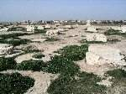  The Apadana of Susa | Susa (Šušim): capital of Elam, favorite residence of the Persian king Darius I the Great. Photos of Susa can be found here.  Susa is one of the oldest cities in the world. Excavations have established that people were living at the acropolis in 5000 BCE and have shown the existence of urban structures about 4000, and it is reasonable that the town, situated on a strip of land between the rivers Karkheh (Choaspes) and Dez (Eulaeus), was already the political center of Elam in the fourth millennium.
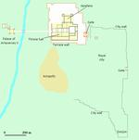 | It has partly been overbuilt with a modern castle that was used by the French archaeologists.  A second part of the city is now called the royal hill. From written sources, we know that there must have been ziggurat, which must have stood somewhere over here. A third part is the artisan's quarter, which was to the east of the buildings on this map. The ruins of a donjon on a steep hilltop in the southeast date back to the earliest period.
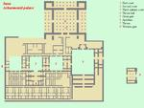  Achaemenid palace (©**) | The Assyrian king Aššurbanipal destroyed the Elamite capital between 645-640 BCE. It is unclear what happened in the next century, but after this, Susa was one of the empires of the Achaemenid empire. The city was rebuilt by the Persian king Darius the Great (522-486). The Apadana palace was clearly his favorite residence. The Greek researcher Herodotus of Halicarnassus, who wrote a lot about the Achaemenid empire, did not know of another capital.
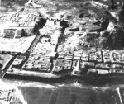  Model of Susa (From W. Hinz,  Darius und die Perzer, 1976;  ©!!!) | The scene of the Biblical book of Esther is laid in Susa, where king Ahasverus (Xerxes) resides. Archaeologists have been able to identify several ruins with buildings mentioned by the author of Esther.  On the picture, the Apadana palace is visible at top left. There were three courtyards, two entrance gates and an apadana (audience hall), the roof of which was supported by 36 columns inside abnd 36 columns outside.  Unfortunately, a big fire during the reign of king Artaxerxes I Makrocheir (465-424) destroyed much of the buildings from this age. The city was rebuilt, however, and continued to be in use for centuries, although at some stage, the people settled closer to the river.  The ancient city could be excavated in the twentieth century. Unfortunately, even the ruins were not left alone: they were partly destroyed during the First Gulf War.
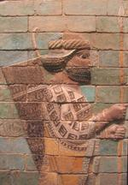  Persian soldier, from Susa  (Louvre, Paris) | This was the place of the famous incident told by Herodotus:  When Darius was king of Persia, he summoned the Greeks who happened to be present at his court, and asked them what they would take to eat the dead bodies of their fathers. They replied that they would not do it for any money in the world. Later, in the presence of the Greeks, and through an interpreter, so that they could understand what was said, he asked some Indians of the tribe called Callatiae, who do in fact eat their parents' dead bodies, what they would take to burn them. They uttered a cry of horror and forbade him to mention such a dreadful thing.  [Herodotus, Histories 3.38;  tr. Aubrey de Selincourt]
King Artaxerxes II Mnemon (404-358) built a second audience hall on the opposite bank of the river, which is visible at bottom left of the picture.
The conical structure in front is more recent. Here, muslims venerate the tomb of the prophet Daniel, another figure related to the Persian court at Susa. In fact, there were other capitals (Pasargadae, Persepolis, and Ecbatana), but is evident that Susa was more impressive. An inscription in the palace, known as DSf, describes how Darius built his residence.
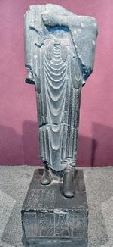  Statue of Darius, once erected  in Egypt, but later brought  to Susa. (Archeological  Museum of Tehran) | A great god is Ahuramazda, who created this earth, who created yonder sky, who created man, who created happiness for man, who made Darius king, one king of many, one lord of many.  Darius the King says: By the favor of Ahuramazda I built this palace.  Darius the King says: Ahuramazda, the greatest of the gods created me, made me king, bestowed upon me this kingdom, great, possessed of good horses, possessed of good men.  By the favor of Ahuramazda, my father Hystaspes and Arsames my grandfather - these both were living when Ahuramazda made me king in this earth.  To Ahuramazda thus was the desire: he chose me as his man in all the earth; he made me king in all the earth.  I worshipped Ahuramazda. Ahuramazda bore me aid. What was by me commanded to do, that he made successful for me. What I did, all by the favor of Ahuramazda I did.  This palace which I built at Susa, from afar its ornamentation was brought. Downward the earth was dug, until I reached rock in the earth. When the excavation had been made, then rubble was packed down, some 40 cubits in depth, another part 20 cubits in depth. On that rubble the palace was constructed.  And that the earth was dug downward, and that the rubble was packed down, and that the sun-dried brick was molded, the Babylonian people performed these tasks.  The cedar timber, this was brought from a mountain named Lebanon. The Assyrian people brought it to Babylon; from Babylon the Carians and the Yaunâ [=Greeks] brought it to Susa. The yakâ-timber was brought from Gandara and from Carmania.  The gold was brought from Lydia and from Bactria, which here was wrought. The precious stone lapis lazuli and carnelian which was wrought here, this was brought from Sogdia. The precious stone turquoise, this was brought from Chorasmia, which was wrought here.  The silver and the ebony were brought from Egypt. The ornamentation with which the wall was adorned, that from Yaunâ was brought. The ivory which was wrought here, was brought from Nubia and from India and from Arachosia.  The stone columns which were here wrought, a village named Abiradu, in Elam - from there were brought. The stone-cutters who wrought the stone, those were Yaunâ and Lydians.  The goldsmiths who wrought the gold, those were Medes and Egyptians. The men who wrought the wood, those were Lydians and Egyptians. The men who wrought the baked brick, those were Babylonians. The men who adorned the wall, those were Medes and Egyptians.  Darius the King says: At Susa a very excellent work was ordered, a very excellent work was brought to completion.  Me may Ahuramazda protect, and Hystaspes my father, and my country.
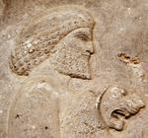  An Elamite with a cub  (relief from Persepolis) | This text interesting because it mentions many nations. The palace was clearly meant as propaganda, where every visitor would be impressed by the size of the empire. An inscription, D2Sa, records reconstruction works from the age of Artaxerxes I Makrocheir and Darius II Nothus.  After the fall of the Achaemenid empire and the reign of Alexander the Great, who married in Susa (text), the city became part of the Seleucid empire. It was now called Seleucia on the Eulaeus. A palace in Greek style was erected, next to Darius' palace. The administrative center, however, was in the southern part of the city, where nearly all Greek and Parthian inscriptions were discovered. In the Parthian age, the city minted coins. The city remained important until the thirteenth century CE. Excavation started in 1897.  Literature  R. Boucharlat, "Susa under Achaemenid Rule" in: John Curtis (ed.) Mesopotamia and Iran in the Persian Period: Conquest and Imperialism 559-331 BC (1997 London) 54-67

 | Susa (1)
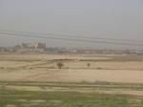 | Susa, seen from the east. The capital of ancient Elam, situated on a strip of land between the rivers Karkheh (Choaspes) and Dez (Eulaeus), is in the hottest part of Iran, Khuzestan. Even in March, the light is more intense than we have ever experienced, and we found it difficult to take photos, so the pictures on this page are a of a rather poor quality.
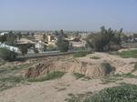 | Another complication is that the troops of Saddam Hussein bombarded this site during the First Gulf War (1980-1988), so that many architectural remains are badly damaged. We will improve these pages in May 2005.  This picture shows modern Susa, from the terrace of the ancient city.
 | A map of the Achaemenid palace.
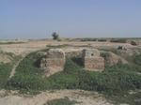 | This is the western gate of the royal palace, which is situated on a hill. When the Persian rulers took over Elam, they built started to live in Susa. A palace was built by Darius I the Great. A terrace was made (cf. the terrace at Persepolis) with very deep foundations.
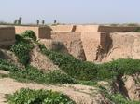 | This picture shows the foundations.
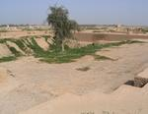 | From the western gate, one proceeds to the first of three courts. This court gives access to...
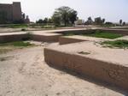 | ... an antechamber. Here, a famous inscription (known as DSf) was found, in which Darius describes how he had constructed the palace and mentions the nations of his empire (text).
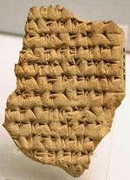 | A similar text, found on a clay tablet, lists the satrapies. This tablet is now in the British Museum. The full text can be found here.
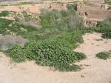 | This is the second court from the southwest. Archaeologists have tried to reach lower, pre-Achaemenid stratums. That's why it looks so deep.
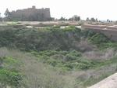 | The second court from the northeast. The big building in the background is the castle that the French archaeologists built. Many precious objects from this excavations are now in the Louvre, Paris, like the beautiful mosaic of glazed bricks below.
 | 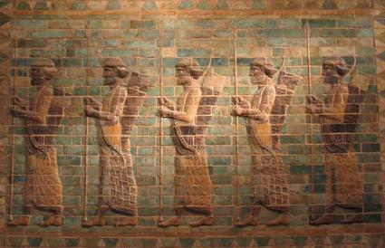

Susa (2)
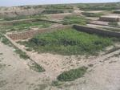 | Adjacent to the second court are two smaller rooms without entrance. The only access can have been from above. This suggests that these rooms were treasuries. When Alexander the Great captured Susa in December 330 BCE, he found some 40,000 talents of precious metal.
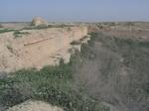 | The northern wall of the third court, which was larger than two first courts. The strange round holes may have been used for flagpoles and this court may have been used for military exercises.
 | A relief of one of the guards, now in the Louvre in Paris.
 | From the second and third courts, it was possible to reach the Apadana or audience hall. Here, the great king received his visitors, and there are many stories that deal with this room (example). There were 36 large columns and the hall measured 109 x 109 meters. An inscription, D2Sa, records reconstruction works from the age of Artaxerxes I Makrocheir and Darius II Nothus.
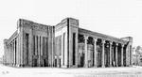 | A reconstruction of the Apadana.
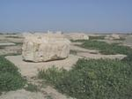 | The Apadana was badly damaged during the First Gulf War (1980-1988). Yet, this column base still suggests something of the original majesty of the building...
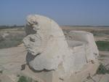 | ... and so does this capital.
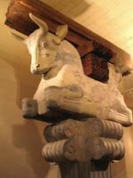 | Fortunately (when happen to live in France) or unfortunately (for the rest of humankind), one has to travel to Paris, to the Louvre, to see an intact capital. This picture was made in the French museum.
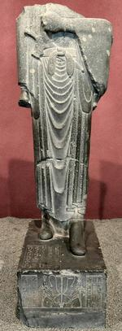 | The citadel of Louvre also has an ancient gate, which was excavated in the 1970's. One of the statues once standing over there has been brought to the Archaeological Museum of Tehran. It is unique, because free-standing statues are rare in Achaemenid art. The statue, which was once covered with paint, is described here.
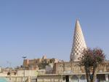 | Susa is mentioned in the Bible in the Book of Esther, and it is possible to walk through the remains of the ancient palace and see the locations of this Biblical story. Esther is said to be buried in modern Hamadan. Yet, there is a Biblical prophet buried in Susa: this conical building belongs to the mausoleum of Daniel.
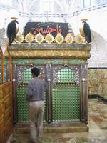 | This is the tomb of the prophet. We visited the sacred place in the week before the festival of mourning that is called Ashura. The black cloth that covers the tomb commemorates the martyrdom of Emam Hussein. To be honest, I found this more impressive than the palace of Darius. For Achaemenid remains, one should visit Persepolis.
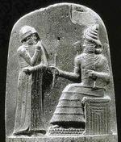 | The best-known archaeological find from Susa is without any doubt the diorite stele with the Laws of the Babylonian king Hammurabi (1792-1750?), which was taken away when the Elamites looted Babylon. The capital shows how Hammurabi prays to Šamaš, the sun god. The significance of the regulations it is still unclear. In a society that was overwhelmingly illiterate, people would never know their rights if they depended upon a written text, and it is possible that the stele was in fact only meant to show to the eternal gods that the king was a just man, or tried to be.

Susa (3)
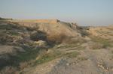 | Like the Achaemenid palaces of Persepolis, Ecbatana, and Dascylium (pictures), the palace of Susa was built on an impressive terrace. This picture shows the remains, seen from the south...
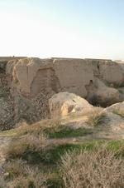 | ... and so does this picture, although this is seen from the southeast.
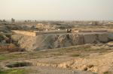 | On top of the terrace, to the east of the palace, was a large gate, which must have resembled the Gate of all nations at Persepolis. Only the foundations were discovered. This gate is mentioned in the biblical Book of Esther. We could not find out how one reached the gate. There must have been a staircase, but where?
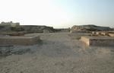 | Inside the gate, seen here from the east, were several columns that carried the roof.
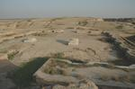 | This picture shows the same gate, seen from the west. In front is the place where the statue of king Darius was found; it is now in the Archaeological Museum of Tehran.
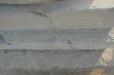 | The column bases contain an Achaemenid royal inscription that is known as XSd, and says: "King Xerxes says: By the grace of Ahuramazda, king Darius, my father, built this portico."
 | A map of the palace of Darius (white), the palace of Artaxerxes II Mnemon, the Acropolis, the Royal city, and the Donjon. The quarters of the artisans was to the east.

Susa (4)
This statue of Darius I the Great was carved in Egypt but later erected near the east gate of the great Achaemenid king's palace in Susa. It is not entirely clear why it was moved from the ancient country along the Nile to the capital of Elam, but a probable explanation is that this happened after 486, when the Egyptians revolted against Darius' son and successor Xerxes. He reconquered the country and it is possible that he carried off the statue of his father from Heliopolis to Susa.
It was excavated in 1972; today, the monument is in the National archeological museum of Tehran.
The statue, which once was covered with paint, is very interesting, because it is the only free-standing sculpture from ancient Persia. (There is one reference to a similar statue of Xerxes in Persepolis.)
Reliefs are more common. Another interesting element is that it is, in fact, an empire list: an enumeration of nations subject to the great king. The difference with the more regular examples of this literary genre (examples) is that the names of the nations are written in hieroglyphs.
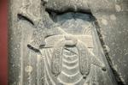 | The belt of the statue of king Darius the Great, inscribed with hieroglyphs spelling his pharaonic name. The inscription is known as DSab and runs like this:
A great god is Ahuramazda, who created this earth, who created yonder sky, who created man, who created happiness for man, and who made Darius king.
This is the statue, made of stone, which Darius ordered to be made in Egypt. This is how everyone who will see this in the future, will know that the Persian man ruled in Egypt.
I am Darius, the great king, king of kings, king of all peoples, king in this great earth far and wide, the son of Hystaspes, an Achaemenid.
King Darius says: May Ahuramazda protect me and what I did!
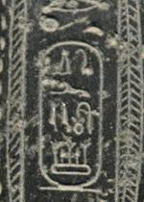 | This is a close-up of the cartouche and the hieroglyphs, which read drjwS.  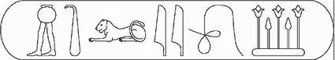
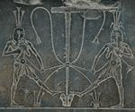 | The central scene on the base of the statue of Darius the Great. The figure that is represented twice is the god Hapi, shown in his Upper and Lower Egypt mode. (He has breasts to indicate the fertility.) Hapi is seen "binding together" the country of Egypt using the iconographic plants which signify the Two Lands - a lotus and papyrus plant. This stands for "uniting" the country, a regnal power motif of divine power since at least the Middle Kingdom.
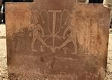 | In other words, Darius presents himself in truly Egyptian style. However, he also seems to have carried a lotus flower and a staff in his hands, common Persian symbols. A pharaoh would have carried other attributes.  This picture shows the rear side of the base of the statue.
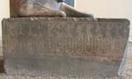 | The left-hand side of the base of the statue of Darius the Great: the empire list.  Below are all figures. Figures looking to the right are on the left-hand side, those looking to the left are on the right-hand side.
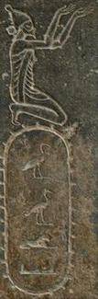 | 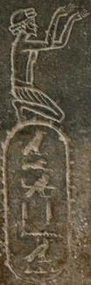 | 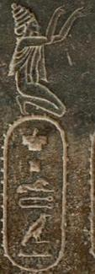 | 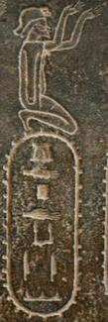 | 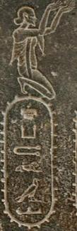 | 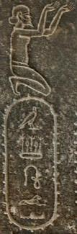
b3b3l  (Babylonia?) | 3lm'yn3  (OP. Armina  = Armenia) | spltj3  (OP. Sparda  = Lydia) | gdpdk3y  (OP. Katpatuka  = Cappadocia?) | sk3tl3  (OP. Skudra  = Thrace?) | 3Sw3l  (Assyria?)
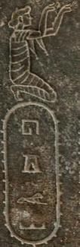 | 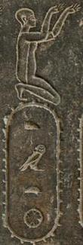 | 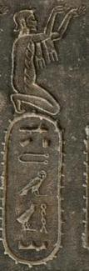 | 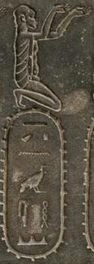 | 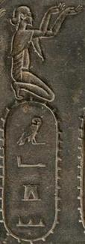 | 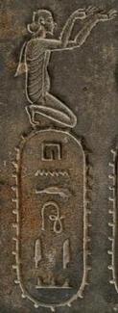
hgl  (Arabia) | kmt  (OE. Kemet  = Egypt) | t3 tjmhw  (OE. Tjemehu  = Cyrenaica) | t3 nhsy  (Nubia) | m'g  (Maka?) | hndw3y  (OP. Hinduš  = India)
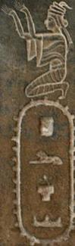 | 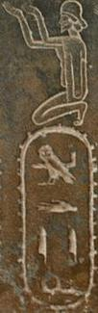 | 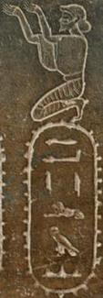 | 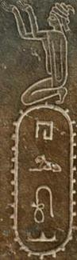 | 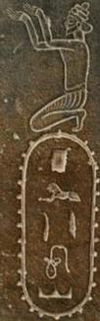 | 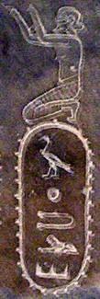
pls | m'dy  (OP. Mâda)  (Media) | '3ylm  "Chiefs of Irem" | hrw3  (OP. Haraiva  = Aria?) | pltiiw3  (OP. Parthava  = Parthia?) | s3htjl
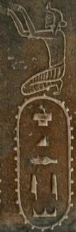 | 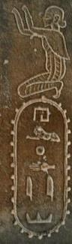 | 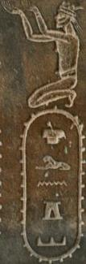 | 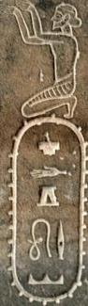 | 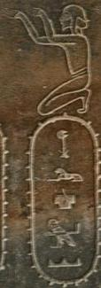 | 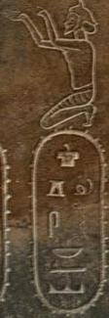
skdy  (OP. Sugda  = Sogdia?) | hlhdy | slng  (OP. Zranka  = Drangiana?) | sdgw3?  (OP. Thataguš  = Sattagydia?) | ch3rs3m'  (OP. Uvârazmîy  = Chorasmia) | sg?shkš  (OP Sâka  = Scythians)

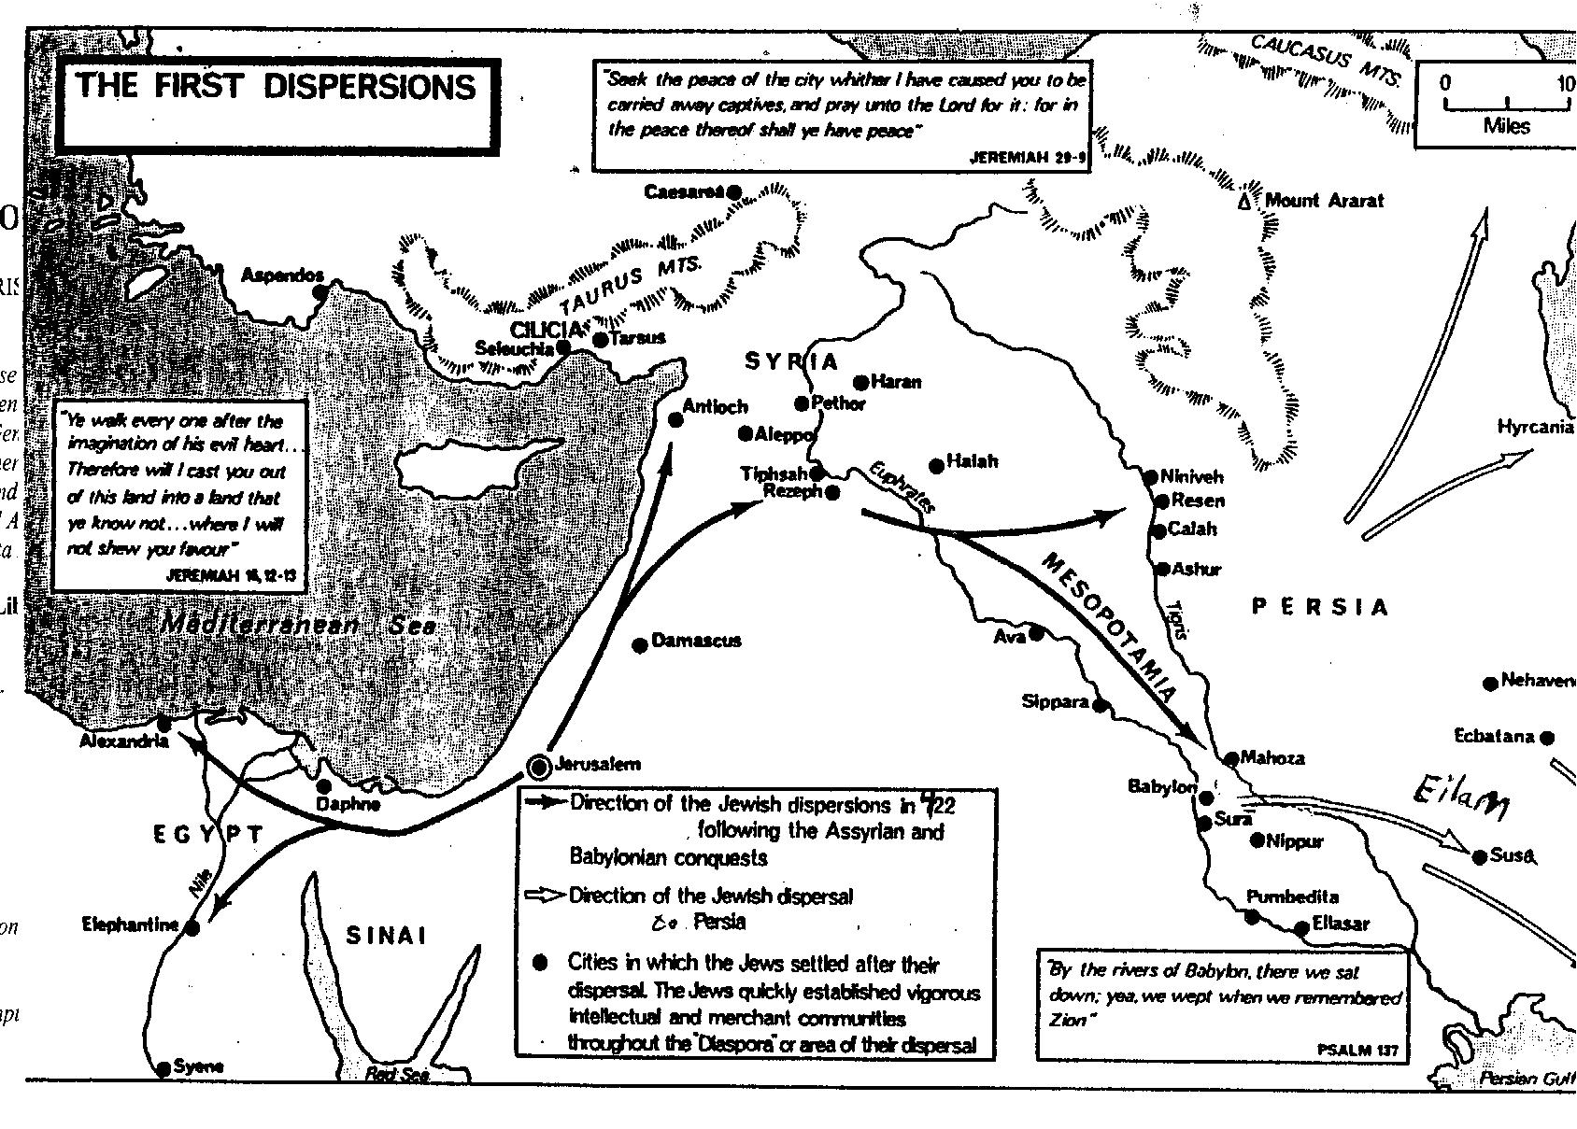
The events detailed in the Book of Esther took place primarily in Shushan, the capital of King Ahasueraus' empire. Shushan is the Hebrew form of the name Susa. Susa was in the area known as Eilam, in what is now Iran. Back then, it was called Bavel (Babylonia). It was part of the empire of Persia and Media. Susa is all the way at the bottom right of the map. Unfortunately, it takes very long to load. (This map is taken, with some small modifications, from page 7 of Martin Gilbert's Jewish History Atlas, published in London in 1969 by Weidenfeld and Nicholson.)
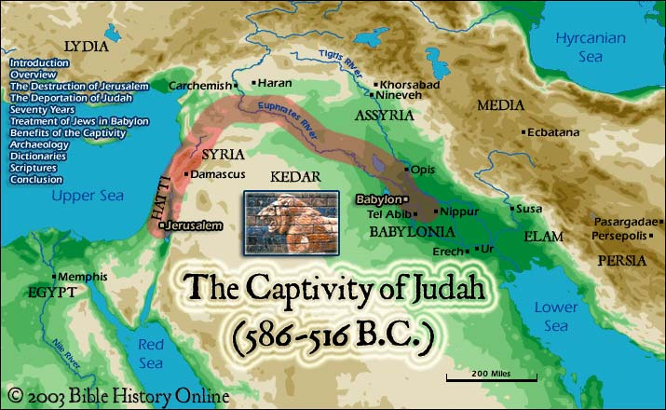

2 Kings 24:20 "For because of the anger of the LORD this happened in Jerusalem and Judah, that He finally cast them out from His presence"

